University of Central Punjab
Faculty of Information Technology

Assignment 1

Course Title: Artificial Intelligence
Course Code: CSAL3243
Name | Registration#

Submission Requirements
- Format: The assignment must be handwritten and submitted as a single document (PDF or Word recommended) in softcopy.
- Integrity: This is an individual assignment. Any evidence of plagiarism or sharing of assignment will result in a zero grade.
- Due Date for Assignment is March 29th, 2026.
- NO LATE SUBMISSION.

CLO# | Course Learning Outcome (CLO) | Taxonomy Level | Mapping to PLO
CLO 1 | To understand and explain the solid fundamental principles and concepts of artificial intelligence, including machine learning and neural networks. | C2 | PLO1

Total Marks =30

Question 1: Compare BFS and DFS in terms of:
- Completeness
- Optimality
- Time Complexity
- Space Complexity
Question 2: Explain Depth-Limited Search and its limitations. How does Iterative Deepening Search (IDS) overcome these limitations?

Question 3: Uninformed Searching
Consider the following search tree:
- A is the initial state
- G is the goal state
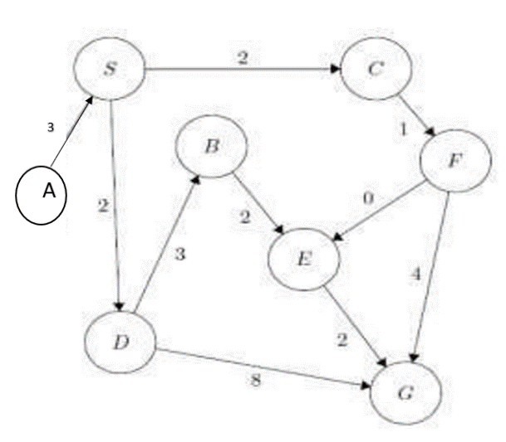
- Each edge is labeled with a cost, representing the cost of moving from one state to another

Task:
For each of the following search strategies:
- Breadth-First Search (BFS)
- Uniform Cost Search (UCS)
You are required to:

(a) Write the sequence of nodes visited (traversal order)

(b) Determine the final solution path from A to G

(c) Calculate the total path cost (for UCS)
Question 4:
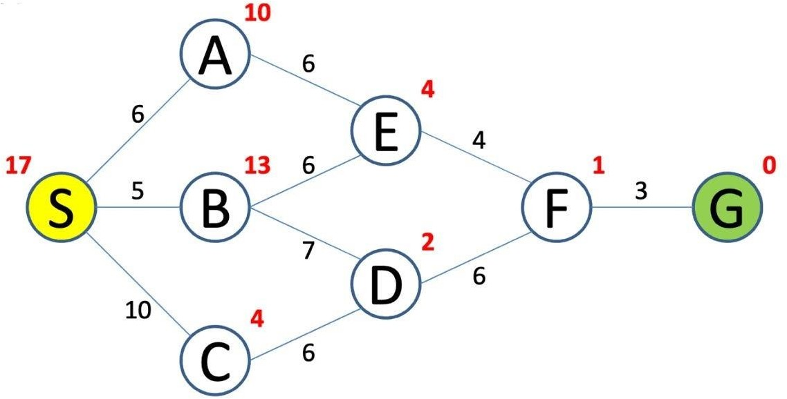
Perform DFS on the graph shown. Explicitly show queue at each step along with a set of explored nodes so far. Are you using a LIFO queue? Which path is found by DFS, is it optimal? Write the expanded nodes in sequence. You may ignore the costs shown for this question.

BEST OF LUCK

